Graphical Residual Analysis
Purpose: Use this job aid to review the three residual analysis tests and examples of the graphical trends.
Within regression analysis, there are three assumptions made about errors and, in turn, three types of residual tests:
- normality of residuals
- randomness of order
- constant variance

Test for normality of residuals
The test for normality of residuals uses a normal probability plot graph to analyze and interpret the results and is based on the assumption that errors follow a normal distribution.
When the residuals follow a normal distribution, they should plot closely along a straight line and indicate a valid regression model.
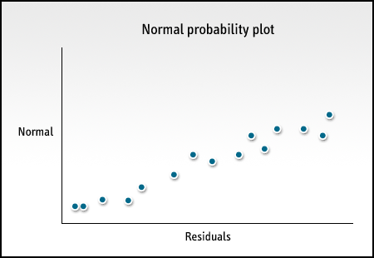
Normal probability plot graph
A fail of the test for normality would be indicated by a clear curve in the data – an s-shape, an inverted s-shape, or a downward curve – or by an evident outlier. These types of displays would indicate that the residuals do not follow a normal distribution, and the model would be deemed not valid.
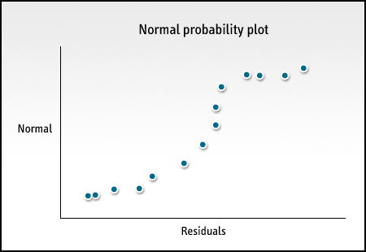
Normal probability plot graph with an s-shape
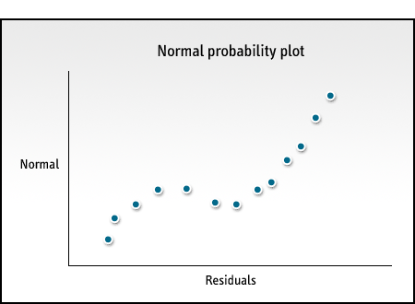
Normal probability plot graph with an inverted s-shape

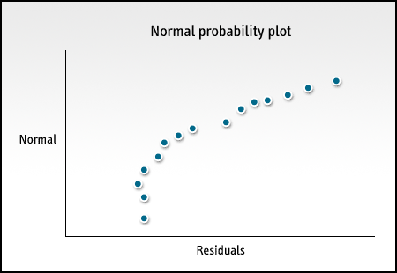
Normal probability plot graph with a downward curve
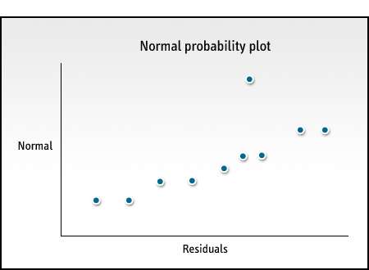
Normal probability plot graph with an evident outlier

Test for randomness of order
The second test is the test for randomness and independence of order and time. This test is based on the assumption that errors are random and independent. They are not affected by the order in which the data is taken.
If the order of your plotted points appears to be totally random with no apparent pattern, then the residuals are independent of each other and the model is valid.
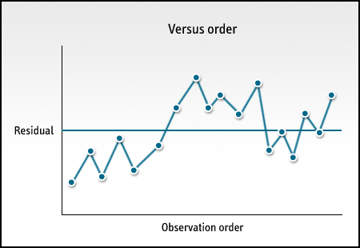
Test for randomness graph
If a pattern is detected, though, it may mean that the residuals are not independent of each other. Common patterns you may find are residuals decreasing as the order they are observed increases or a sudden change in the residual values from left to right and low to high.
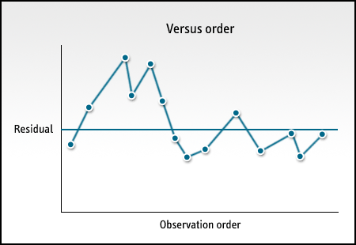
Test for randomness graph decreasing values
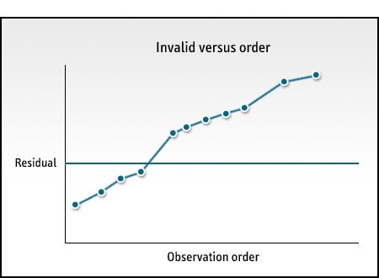
Test for randomness graph sudden shift

Test of constant variance
The test of constant variance examines the third assumption that errors have a constant variance across all values of x.
The first step is to calculate the fitted values using the regression equation. Then you plot the residuals versus the fitted values on a test for constant variance across all values of x graph. The residual values must always be on the vertical axis and the fitted values on the horizontal. When the plotted points appear more concentrated around zero and less so as they move out from the zero line, having no unusual patterns, it indicates a valid regression model.
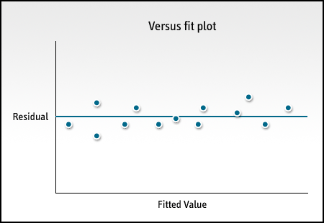
Test of constant variance graph
But if the distribution increases or decreases as the fitted values increase or decrease, then there may be nonconstant variance.
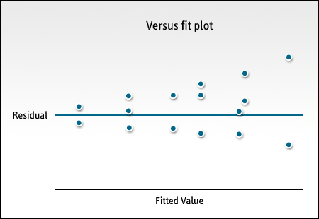
Test of constant variance graph with increasing values
You may also be able to identify an outlier during this test, if you notice an extreme value. Either of these patterns would indicate a fail of the test for constant variance and a regression model that is not valid.
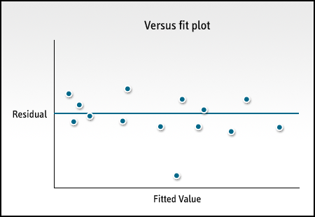
Test of constant variance graph with evident outlier

